--------------------Day 6-----------------

/*1. Categorize products by stock status (Display product_name, a new column stock_status whose values are based on below condition units_in_stock = 0 is 'Out of Stock' units_in_stock < 20 is 'Low Stock')*/

QUERY:

select * from products

select product_id,product_name,units_in_stock, case when units_in_stock =0 then 'out of stock' when units_in_stock <20 then 'low stock' else 'high stock'

end as stock_status from products

group by product_id

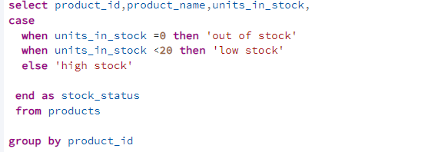

Output:

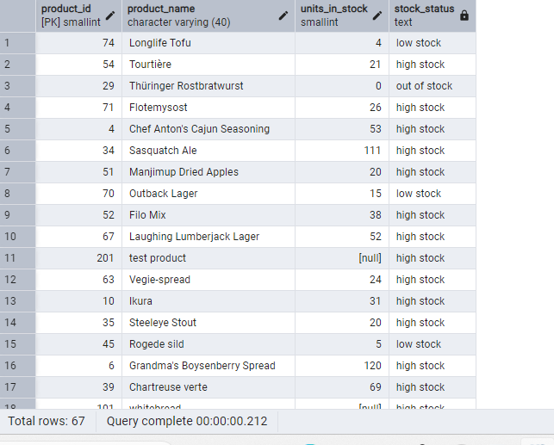

2. Find All Products in Beverages Category (Subquery, Display product_name,unitprice)

Query:

select product_id,product_name from products where product_id in ( select product_id from products p join categories c on p.category_id=c.category_id where c.category_name='Beverages')

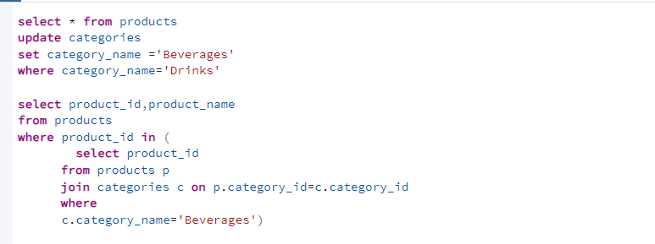Output:

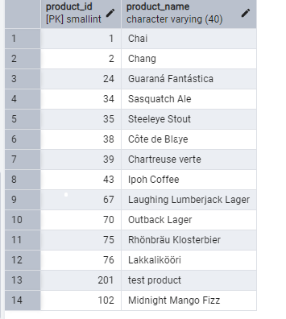

3. Find Orders by Employee with Most Sales

(Display order_id, order_date, freight, employee_id.

Employee with Most Sales=Get the total no.of of orders for each employee then order by DESC and limit 1. Use Subquery)

QUERY:

select order_id,order_date,freight,employee_id

from orders where employee_id = ( select employee_id from orders group by employee_id order by count(*)desc limit 1

)

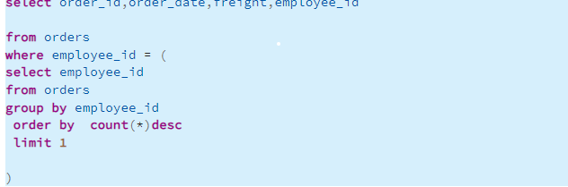

Output:

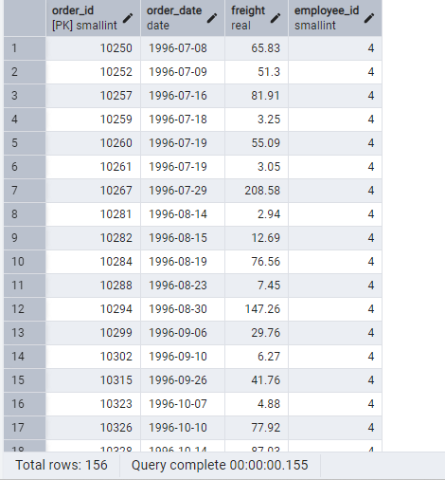

4.Find orders where for country!= ‘USA’ with freight costs --higher than any order from USA. (Subquery, Try with ANY, ALL operators)

select* from orders

--AND---

select order_id,ship_country as country,freight from orders where ship_country!= 'USA'and freight > Any (select freight from orders where ship_country='USA' )

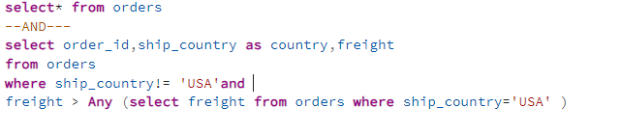Output:

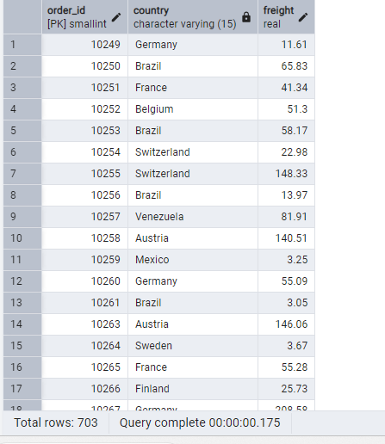

-----ALL---

select order_id,ship_country as country,freight from orders where ship_country!= 'USA'and freight > All (select freight from orders where ship_country='USA' )

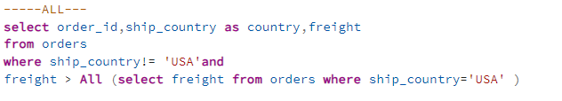Output:

